Experiment No :- 6
Aim :- Create line,bar,pie,and scatter plots using Matplotlib with proper labels and legends.
Roll No:- 60

1. Line Plot
Plotting test scores of Class A and Class B over time.
Program:
import matplotlib.pyplot as plt
# Sample data
x = [1, 2, 3, 4, 5]
y1 = [10, 20, 25, 30, 40]
y2 = [5, 15, 20, 25, 35]
# 1. Line Plot
plt.figure(figsize=(6, 4))
plt.plot(x, y1, label='Class A', marker='o')
plt.plot(x, y2, label='Class B', marker='s')
plt.title('Line Plot: Test Scores Over Time')
plt.xlabel('Test Number')
plt.ylabel('Score')
plt.legend()
plt.grid(True)
plt.show()

Output
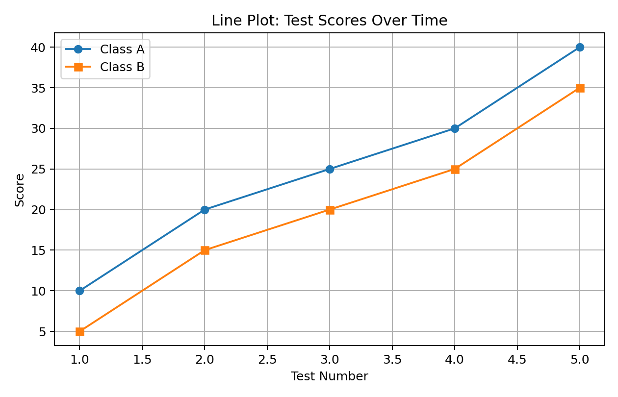

2. Line Plot — For 2 separate graphs
Subtitle: Displaying the test scores for Class A.
Program:
import matplotlib.pyplot as plt
# Sample Data
x = [1, 2, 3, 4, 5]
y1 = [10, 20, 25, 30, 40]
y2 = [5, 15, 20, 25, 35]
# 1. Line Plot
plt.subplot(1,2,1)
plt.plot(x, y1, label='Class A', marker='o')
plt.title('Line Plot: Plot-1')
plt.xlabel('Test Number')
plt.ylabel('Score')
plt.legend()
plt.grid(True)
# 2. Line Plot
plt.subplot(1,2,2)
plt.plot(x, y2, label='Class B', marker='s')
plt.title('Line Plot: Plot-2')
plt.xlabel('Test Number')
plt.ylabel('Score')
plt.legend()
plt.grid(True)
plt.show()
Output :-
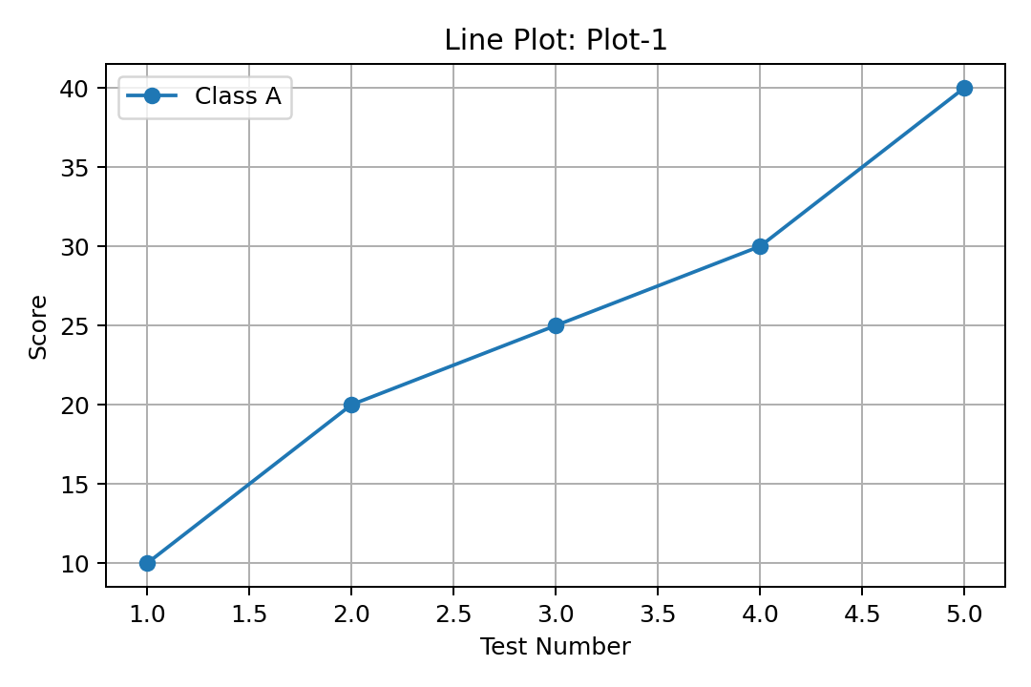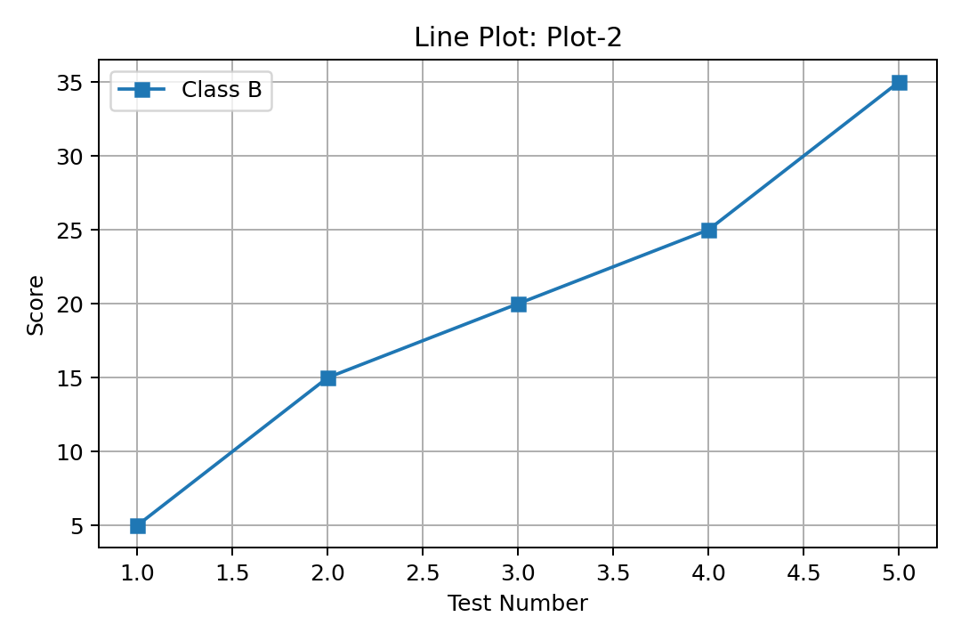

4. Bar Chart
Program:
import matplotlib.pyplot as plt
# Sample Data
categories = ["A", "B", "C", "D"]
values = [30, 20, 25, 25]
# 2. Bar Chart
plt.bar(categories, values, color='orange', label="Category Values")
plt.title("Bar Chart Example")
plt.xlabel("Categories")
plt.ylabel("Values")
plt.legend()
plt.show()
Output
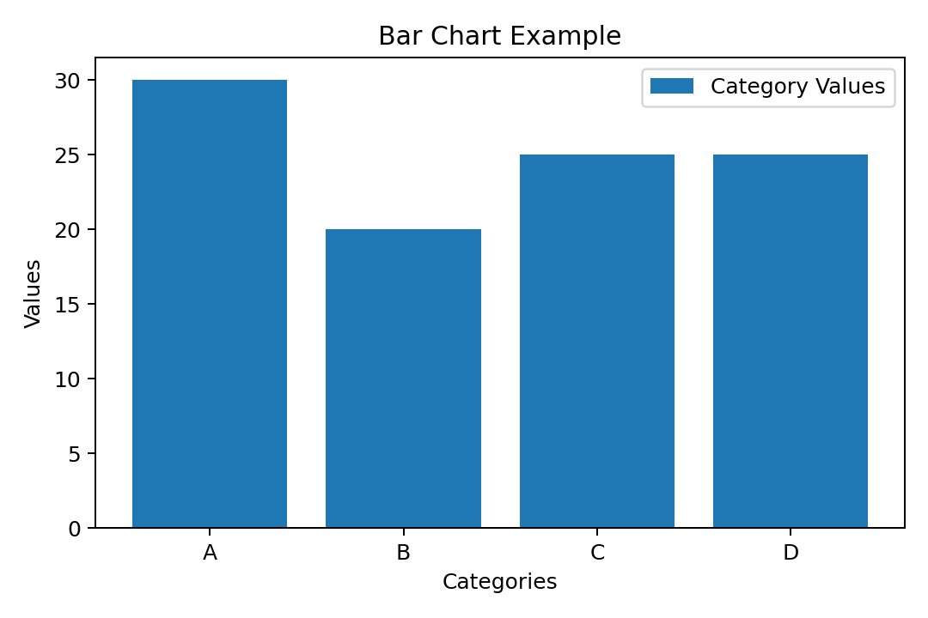

5. Grouped Bar Chart
Program:
import pandas as pd
import matplotlib.pyplot as plt
# Sample data
data = {
'Day': ['Mon', 'Tue', 'Wed', 'Thu', 'Fri'],
'Week1': [50, 60, 70, 40, 90],
'Week2': [45, 55, 65, 75, 85],
'Week3': [40, 50, 60, 70, 80]
}
df = pd.DataFrame(data)
# Grouped Bar Chart
df.plot(kind='bar', x='Day', title='Grouped Bar Chart')
plt.ylabel('Sales in Rs')
plt.show()
Output
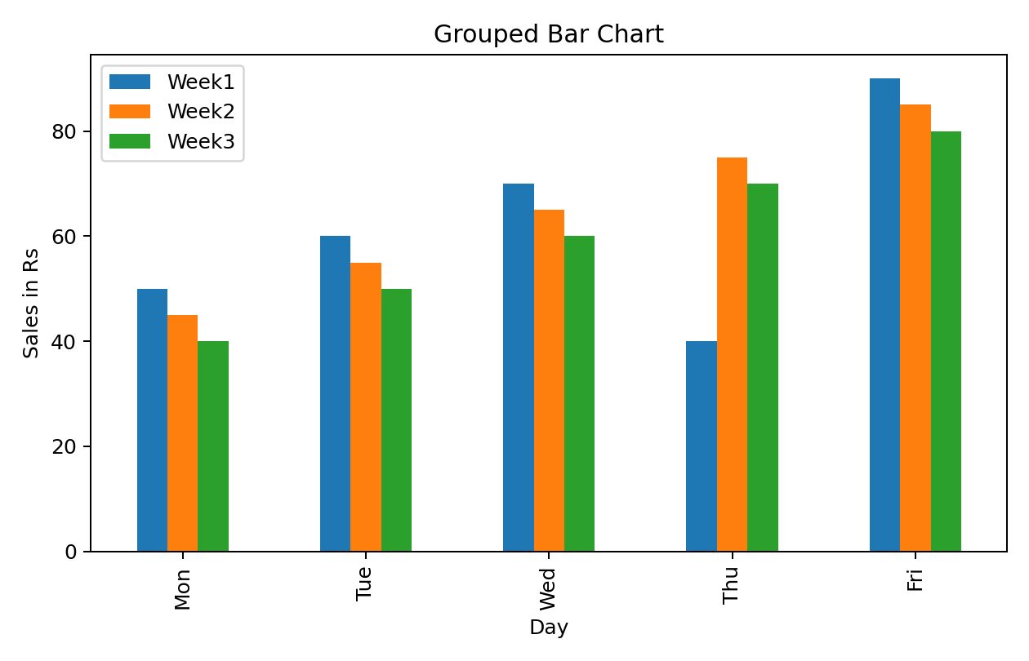

6. Stacked Bar Chart
Subtitle: Showing the combined weekly sales for each day using stacked bars.
Program:
import pandas as pd
import matplotlib.pyplot as plt
# Sample data
data = {
'Day': ['Mon', 'Tue', 'Wed', 'Thu', 'Fri'],
'Week1': [50, 60, 70, 40, 90],
'Week2': [45, 55, 65, 75, 85],
'Week3': [40, 50, 60, 70, 80]
}
df = pd.DataFrame(data)
# Stacked Bar Chart
df.plot(kind='bar', x='Day', stacked=True,
title='Stacked Bar Chart')
plt.ylabel('Sales in Rs')
plt.show()
Output
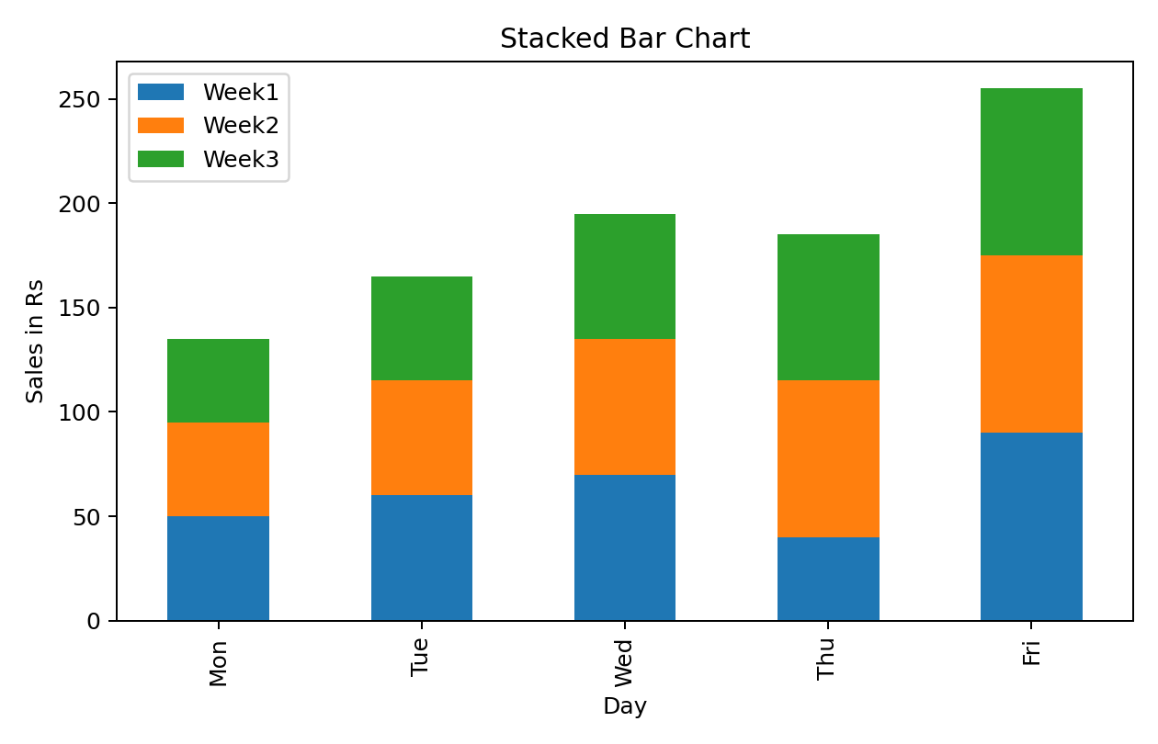

7. Scatter Plot.
Program:
import matplotlib.pyplot as plt
# Sample Data
x = [1, 2, 3, 4, 5]
y = [10, 20, 25, 30, 35]
# 4. Scatter Plot
plt.scatter(x, y, color='red', marker='x',
label="Data Points")
plt.title("Scatter Plot Example")
plt.xlabel("X-axis")
plt.ylabel("Y-axis")
plt.legend()
plt.show()
Output


